|  |  |
| --- | --- |
| ***Manuscript Number:*** | *ENGEO_2019_1117* |
| ***Title (new):*** | *ASSESSING THE SPATIAL VARIABILITY OF GROUND MOTION FOR MICROZONATION PURPOSES: THE CASE STUDY OF CAVEZZO MUNICIPALITY (ITALY)* |
| ***Authors:*** | *Lai1,2 C.G., Poggi3 V.*, Famà1,2 A., Zuccolo1,2 E., Bozzoni2 F.*, Meisina4 C., Boni4 R., Martelli5 L., Massa6 M., Mascandola6 C., Petronio3 L., Affatato3 A., Baradello3 L., Castaldini7 D., Cosentini8 R.M.* |

**Introduction to Review Reply**

*First of all, we would like to express our deepest gratitude to both reviewers for the effort and the time invested in our manuscript. We believe that the proposed suggestions and criticisms are fair and appropriate to improve the overall quality of the submission.*

*In the following, we provide a hopefully satisfactory reply to each issue identified by the reviewers. All critical matters have been considered and, whenever possible, fixed. Major modifications have been highlighted in red in the manuscript, to facilitate the reviewer’s counter-check.*

**Comments to Reviewer #1**

The Paper ENGEO_2019_1117 presents the approach adopted to characterize the seismic response of a village at level III microzonation within the LIQUEFACT project. The topic is conventional, but the Authors collected a large amount of data. It cannot be published in the present state due to some drawbacks, which should be handled by the Authors to improve the overall quality of the paper. The amount of collected data should be emphasized together with a more critical discussion of some of the made choices.

*R: We thank the reviewer for his suggestions, which were certainly essential to improve the overall quality of our manuscript. A detailed review reply is provided separately for each identified issue.*

1. **TITLE**
   1. I was not able to identify the multi-scale in this paper, as only the Cavezzo village is analysed. I suggest to remove from the title.

*R: The definition of multiscale was originally included to highlight the different resolution of the geophysical techniques used during this investigation. However, we agree that this definition might be misleading for the reader, therefore we removed the definition from the title.*

1. **INTRODUCTION**
   1. It is quite limited, as most of it is occupied by the description of the LIQUEFACT project. I suggest to improve it focusing on a brief-state-of art on the topic and discussing the open issues.

*R: [FRANCESCA]*

* 1. Several national and international papers deal with III level microzonation, some of the most recent should be cited.

*R: [VALERIO, ELISA, FRANCESCA]*

* 1. The explanation of the Project should be reduced, the description of the other modelled sites is not necessary.

*R: According to suggestion, the explanation of the Project was reduced and the description of the other case studies was simply removed from the manuscript.*

* 1. Emilia earthquake was studied by several Authors both as seismic sequence and for the liquefaction occurrence, some reference are mandatory.

*R: We added some relevant references to the manuscript, as suggested.*

1. **GEOLOGICAL AND SEISMOTECTONIC SETTING**
   1. It is sufficiently synthetic and informative, but I think some reference on the buried structural setting are necessary.

*R: [CLAUDIA]*

* 1. A geological cross-section of the study area is necessary.

*R: A new map with geographical location of the study area and a geological cross section has now been included, as requested.*

1. **METHODOLOGY**
   1. The methodology is a difficult to follow, I suggest to summarize it, through bullet points.

*R: We agree that the methodology section was likely confusing for a reader not familiar with the project. We have indeed deeply rewritten it and reorganized in major bullet points.*

1. **GROUND CHARACTERIZATION DATASET**
   1. The dataset is made of a large amount of tests and data. I suggest to provide a synthetic table with all the relevant information in order to better highlight the high number of data.

*R: As suggested by the Reviewer, Table 2 including the type and number of tests adopted for the ground characterization of the territory of the Cavezzo Municipality, was added in the manuscript. [IS THAT REALLY WHAT HE WANTED? I SUGGEST SOMETHING MORE INFORMATIVE]*

* 1. The sentence on INGV and OGS is not necessary, it could be moved in the Acknowledgments.

*R: We have modified the sentence in the manuscript in order to clarify the role played by INGV and OGS in the ground characterization of the Cavezzo territory avoiding words typically adopted in the Acknowledgments. Researcher from INGV and OGS are co-authors of this paper so the authors think that there is no need to mention INGV and OGS in the Acknowledgments. This sentence is also in our opinion necessary to introduce the origin of the two complementary profiles discussed in the following sections.*

1. **MODELING OF THE SUBSOIL**
   1. It is not properly clear how MOPS were identified. Further details should be provided, together with typical stratigraphic logs. Aren't 9 MOPS too much for a small area as the analyzed one? Is the geology so heterogeneous?

*R: The MOPS have been identified using an approach described in detail in the work introduced by Meisina et al. 2019, which includes also the typical stratigraphic logs for each MOPS. In our opinion, a detailed description of such approach is beyond the scope of this summary work and we refer to the aforementioned paper for further details. [I WOULD EXTEND THIS POINT, AT LEAST DESCRIBING THE DIFFERENT ZONES 1-9]*

* 1. Is the seismic bedrock represented by the Blue Clays? Please state it clearly.

*R: [CLAUDIA]*

* 1. The Authors should consider to discuss the results of their soil characterization with this VS30 map of Italy produced by other Italian authors: <https://www.sciencedirect.com/science/article/pii/S0267726118311114>

*R: The work done by Forte et al. 2019 is certainly very interesting and results are definitely valuable. Nonetheless, the referenced work is in our opinion meaningful for those analyses requiring a robust -although coarse- soil classification over very large areas, such is the case for PSHA at national level. Such approach is incompatible with the level of detail required by the proposed investigation. It is to mention that, although a reasonable matching of the Vs30 value has been found by the authors, we think that presenting and discussing such comparison would not be pertinent.*

*We nonetheless thank the reviewer for the suggestion, which we appreciate and which we will definitely investigate further in a separate work presently ongoing for the Friuli region.*

* 1. Please provide a more critical discussion on the use of 1d-linear equivalent approach, because its use could be questionable and the results inaccurate, in particular due to layer geometry and close hypocentral distance earthquakes.

*R: Two-dimensional linear-equivalent ground response analyses were carried out with reference to two representative vertical cross-sections using QUAD4M (Hudson et al., 1994). From the comparison of the results from 1D and 2D ground response analyses, it was inferred that for the frequencies of interest in the microzonation study, 2D effects are negligible. A few sentences are included in the manuscript on this issue.*

*Concerning the limits of the linear-equivalent constitutive model for the soil, the authors think that they are quite deeply discussed in Section 8.*

*Finally, the reference seismic hazard at the site was defined according to the probabilistic framework, as specified by the current Italian building code (NTC, 2018), for three return periods (475, 975 and 2475 years).*

1. **RESULTS**
   1. Few sentences on the choice of using these parameters to characterize the amplification should be added.

*R: The amplification factors have been computed following the prescriptions of the Emilia Romagna guidelines (2015, DGR n.2193), which have been better referenced in the paper.*

1. **DISCUSSION AND CONCLUSIONS**
   1. Some consideration on the areas where liquefaction occurred and the value of seismic acceleration or amplification in the same could be very interesting.

*R: [SEE ALSO POINT 9 OF THE SECOND REVIEWER]*

1. **FIGURES**
   1. The symbols for the fluvial elements are very similar and confusing. Try to differentiate more, i.e. ridge less and more than 2m. The DEM resolution is not clear, use the higher resolution (as in fig. 2) or insert contour lines.

*R: [ANTONINO, the plot should still be improved]*

* 1. Fig. 2 is filled with information, you could consider to produce n. subfigure for each kind of investigation.

*R: Information in Figure 2 (now Figure 3) has been redistributed in 3 consecutive plots, to facilitate the reader to distinguish between pre-existing and newly-made investigations from different sources. [[ANTONINO, the plot should still be improved]*

**Comments to Reviewer #2**

This manuscript presents a summary of the research activities on seismic microzonation of Cavezzo municipality. Authors apply a multidisciplinary approach to estimate pseudo 3D seismic velocity model under the municipality and utilize for amplification factors. Author mention broad range of methods and results. In general, I feel that the topic of the paper is interesting and should be of interest to readers of Engineering Geology. My modest criticism is that the manuscript reads rather as an overview of a project, not as regular research paper. The development of the 3D model is insufficiently described, the descriptions do not go into detail. It would be difficult for interested readers to apply suggested procedures. The transferable “lessons learned” should be presented as well. Therefore, I recommend a revision of the manuscript. Authors should focus on more detailed descriptions of the new significant approaches. They should clearly specify what are inputs (and outputs) of the current study, and cite papers or reports which include details on these inputs (velocity models, results of MASW, electric tomography …).

*R: We would like to thank the reviewer for the appreciation to our work. We agree that some sections were insufficiently detailed, while other sections were filled with project details not necessarily useful or interesting for the reader. According to suggestion, we underwent a hopefully satisfactory revision of the manuscript.*

**Specific comments:**

1. Title is too long and not very attractive.

*R: The title has been considerably shortened, according also to suggestion of reviewer #1.*

1. Abstract should be rewritten, it is too general and reads rather as an introduction and not the summary of the paper. It should be focused on specific scientific objectives and results.

*R: We agree with the reviewer that the abstract appears to be not very informative and some refocusing is necessary. The introductory part on the project LIQUEFT has been therefore considerably reduced, while an additional description of the model implementation has been included.*

1. The development of 1D seismo-stratigraphic profiles should be described in more detail – an example in the manuscript would be helpful.

*R: As requested, the section about the seismo-stratigraphic model has been considerably rewritten and extended, providing in particular more details on the definition of the velocity model.*

1. How the OGS model compares with measured H/V? Is the velocity jump present in the INGV model necessary to fit observed H/V?

*R: As it is now better described in the section about the seismo-stratigraphic model construction, the INGV model is constrained by the combined used of dispersion (L+R), ellipticity (R) and f0 (this last coming directly from H/V analysis). The model therefore compares well to H/V ratio in the low frequency range, where a good match between H/V and Rayleigh ellipticity is generally expected (the “right flank” of the curve). For the benefit of the reviewer, it is here provided a comparison of the modelled ellipticity (coloured lines) versus mean H/V at the centre of the array (scaled by square root of 2).*

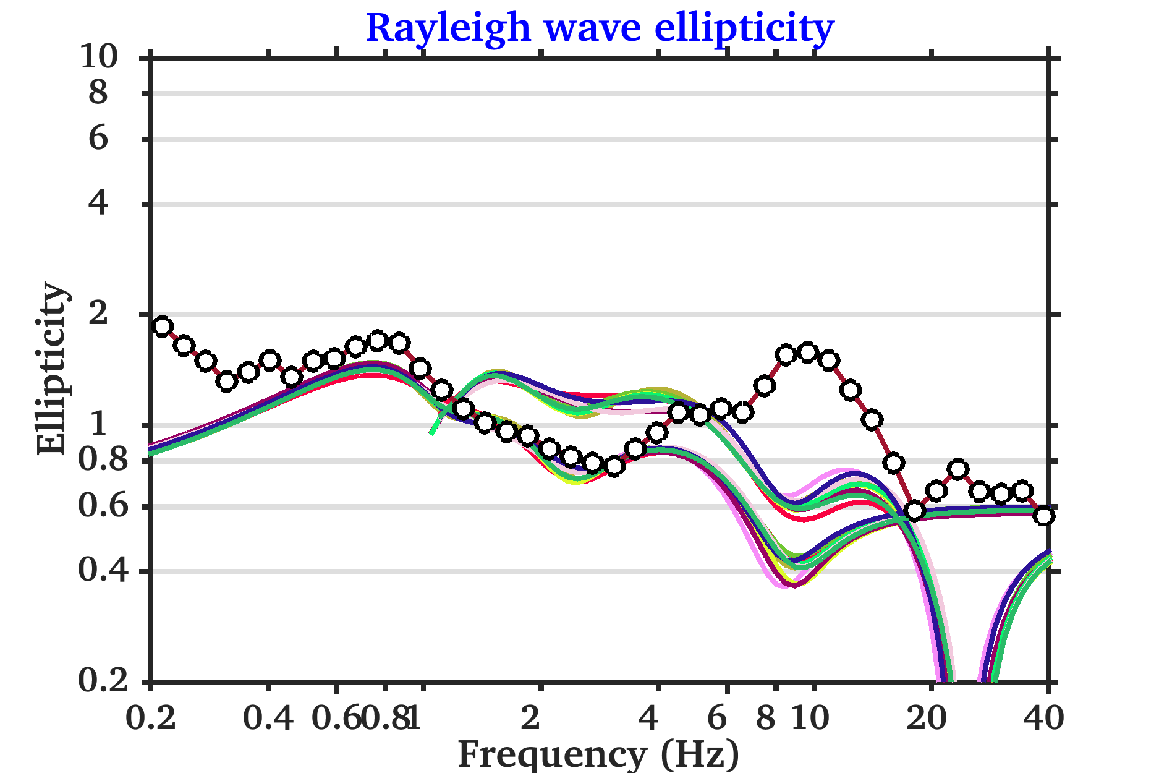

*To answer the original reviewer question, the jump in the profile is then necessary to fit the ellipticity information for the INGV model (which is indeed inverted using the ellipticity), while the OGS model (from reflection seismic) produces a frequency peak of less comparable amplitude, which is might be due to the lower contrast of impedance, but also to other balancing effects such as intrinsic attenuation.*

*We would like to stress, however, that we did not included such discussion in our manuscript because this is the topic of a separate publication by the same authors where the performances of active and passive methods are more critically compared and analysed.*

1. Page2: “The resolution scale in grade 1 microzonation is low.” Please be more specific.

*R: The sentence was removed from the manuscript since it is simply a repetition indicating that grade 1 is a basic level.*

1. Section 5.3: “For that, a map of the surface Rayleigh wave velocity variability was first obtained by interpolating the VS30 estimates from 83 MASW analyses (Figure 6).” It is not very clear what has been done? Do you mean shear wave velocity instead of Rayleigh wave velocity?

*R: We apologize for the confusing mistake, which made the description very unclear. The sentence has been corrected to: “To constraint the shallow portion of the velocity model, a map of the Vs30 variability was first obtained from existing MASW analyses from 83 previous surveys”. Moreover, additional explanation of the methodology has been added to the end of the section.*

1. Section 5.3: “Spatial interpolation of the VS30 values was performed using Geostatistics” Geostatiscs is name of a software? Please specify.

*R: We apologize again for the mistake. The sentence has been reformulated to “Spatial interpolation of the VS30 values was subsequently performed using widely used geostatistic algorithm, i.e. ordinary Kriging (Isaaks and Srivastava, 1989).”*

1. Section 5.5: The details on soil samples tested in laboratory are not presented at all (material type etc.). The Figure 7 has no meaning in this way. Is this sample representative for the entire area? Please comment in the text.

*R: [FRANCESCA, ELISA]*

1. The amplification map should be briefly discussed (what is exactly the origin of the ground motion variability etc.).

*R: [ELISA]*

1. The quality factors are not discussed in the paper at all.

*R: [ELISA]*

1. Figure 1: Coordinate system (datum & grid) is not specified. Contours might better represent terrain as the colour scale interferes other features in the map.

*R: [ANTONINO]*

1. Figure 2: Same as for Figure 1, contours might better represent terrain as colourful scale interferes other features in the map. Moreover, color scale used for DTM differs from the one used in Figure 1.

*R: [ANTONINO]*

1. Figure 3: Zone characteristics are not presented in the text. It is then impossible to understand the final results presented in Figure 8.

*R: [ANTONINO]*

1. Figure 4 is difficult to read, it is not specified what it shows. The variability of the top layers is not visible. Colour coding is not presented.

*R: We agree that the figure was poor. A new plot has been created, better presenting the geometry of the modelled layer and, in particular, of the reconstructed seismic bedrock. [ONGOING]*

1. Figure 7: remove, see my comment above.

*R: [FRANCESCA, ELISA]*