**3.1- Seismic hazard in Sub-Saharan Africa**

**Introduction and Goals**

The East African Rift System (EARS) is the major active tectonic feature of the Sub-Saharan Africa (SSA) region. Although the seismicity level of such a divergent plate boundary can be described as moderate, several damaging earthquakes have been reported in historical times, and the seismic risk is exacerbated by the high vulnerability of the local buildings and structures. Formulation and enforcement of national seismic codes is therefore an essential risk mitigation strategy.

Nonetheless, a reliable risk assessment must be based on an updated and reliable seismic hazard model for the region. The last published regional model for SSA was developed within the frame of the GSHAP project and is almost 20 years old (Midzi et al., 1999). Nowadays, the availability of new data, local and regional seismotectonic studies and recently developed methods and tools prompt the development of a new PSHA model summarizing the current state of knowledge in Sub-Saharan Africa.,

The development of a regional model cannot be done without the contribution of experts from the local scientific community. Partnership with local governmental institutions and authorities is also an essential step to facilitate model acceptance and for potential integration with national seismic codes. Following this concept, GEM works at engaging with the local communities and building and extending awareness on seismic hazard and the technical capacity for the use of GEM’s open tools and resources.

In the section we describe the implementation of a community-based probabilistic seismic hazard model for the Sub-Saharan Africa, developed with the contribution and resources from African scientists primarily involved in initiatives promoted by AfricaArray.

**Methodology**

The methodology adopted for the construction of the hazard model for Sub-Saharan Africa follows a classical approach, which extensively relies on geological and tectonic information and on a catalogue of past seismicity.

Since several catalogues are available for the study area, we homogenized the collected information (location solutions, reported time, intensity scale) using a set of objective criteria for selection, merging and homogenisation. GEM has recently developed a set of open-source tools that helps scientists going though the catalogue harmonisation process. In this study we make use of these tools (GEM Catalogue Toolkit, Weatherill et al. 2016) to produce a state-of-art earthquake catalogue for Sub-Saharan Africa with homogenous magnitude representation (Mw). Such catalogue (hereinafter SSA-GEM, Figure 1) is obtained by augmenting available global catalogues (e.g. ISC-Reviewed, ISC-GEM, GCMT) with information from local agencies and regional projects (the Tanzanian broadband seismic experiment, the Ethiopian plateau catalogue and the Eastern Africa seismic experiment), particularly from the AfricaArray framework.

The current SSA model has been built on the most recent and up to date information available from scientific literature, global bulletins and local earthquake catalogues, such as those from the partner project AfricaArray. Despite the progress made in collecting and interpreting active fault data, the information currently available in Sub-Saharan Africa does not permit the construction of a comprehensive fault-based hazard model. For this reason, we decided to develop the new model for the Sub-Saharan Africa region using a number of seismically and tectonically homogenous earthquake source zones. In its simplest representation, each source is considered independent from others and the earthquake rupture process within zones is assumed to follow a Poisson process. Each source is fully described by the geometrical properties (size, location, orientation) of all possible ruptures, and by the definition of their corresponding temporal occurrence behavior. While the former requirements can be directly obtained by analyzing available earthquake recordings (e.g. moment tensor solutions) and from geological and tectonical considerations, the latter has to be calibrated on the evidence of past observed seismicity and through the use of a sufficiently extended earthquake catalogue.

Calculation of seismic hazard was made through the use of the OpenQuake engine (Pagani et al., 2014), an open source seismic hazard and risk calculation software developed, maintained and distributed by the Global Earthquake Model Foundation. In the next sections we will review the most important results and products of the SSA model.

**Main Results**

*The SSA-GEM homogenized catalogue*

The final catalogue consists of 29803 earthquakes with magnitude in the range 2 ≤ Mw ≤ 7.53. Figure 1 shows the spatial distribution of the epicenters of the earthquakes included in this catalogue. The right panel in the same figure emphasizes the lack of earthquake information collected in Sub-Saharan Africa before the 1960s.

*Seismic Source Zones*

The current area source model (figure 2) consists of a total of 19 zones distributed over 6 main tectonic groups, which we assume of homogenous rheological and mechanical behavior with respect to the underlying crustal geology. Seismic zones have been delineated by considering the distribution of observed seismicity (from SSA-GEM catalogue) and the geological/tectonic characteristics of the study region. For each zone, we defined source mechanism (strike, dip and rake), depth distribution and seismicity parameters for a double truncated Gutenberg-Richter magnitude-frequency distribution (a- and b-values, maximum magnitude MMAX, e.g. figure 3).

*Probabilistic Hazard Calculations*

The investigated area consists of a mesh of 79109 sites spaced at approximately 10 km. Such area includes the earthquake source zones of the model, plus a buffer region of not less than about 100 km. For each site of the mesh, free rock conditions are assumed, with a fixed 30-metre averaged shear-wave velocity (Vs30) reference of 600 m/s (corresponding to stiff soil transition in EC8 and NERHP classification).

Target ground motion intensity for calculation is 5% damped response spectral acceleration (in g), estimated for probabilities of exceedance of 10% and 2% within an investigation time of 50 years. This corresponds respectively to return periods of about 2474 and 474 years. Due to the substantial lack of historical records for proper calibration of the large magnitude rates, we avoid using longer return periods.

According to the possibilities of the selected GMPEs, spectral acceleration has been computed at PGA and for the response spectral periods of 0.05s, 0.1s, 0.2s, 0.5s, 1s and 2s. Ground motion integration has been conservatively truncated at 3 sigma of the prediction. Output of the calculation are mean and quantile (0.15, 0.5 and 0.85) hazard curves at each site, together with Uniform Hazard Spectra (UHS) and hazard maps (e.g. Figure 4 and 5).

*The Strain Rate Model*

To compensate the general lack of information on long-period earthquake occurrence, we experimented the use of strain rate information. A strain-rate model for the EARS has been developed by Stamps et al. (2015) in the frame of the GEM Strain Rate Project (figure 6). The model has been created using geodetic data from continuous GPS measurements and it is characterized by an innovative definition of the deforming regions guided by observed seismicity distribution. We used the strain rate model results for the construction of the area source model. In addition, the original goal was to use the geodetic strain rates also to derive estimates of total scalar moment release, subsequently used to constrain earthquake recurrence relationships for both area (as distributed seismicity) and fault source models. The rates obtained indirectly from strain rates and more classically derived from the available seismic catalogues are to be compared and combined into a unique mixed earthquake recurrence model, which is subsequently used as the base for seismic hazard calculations. Unfortunately, status of this research is still at very early stage, and no sufficiently reliable results have been yet obtained for consideration into the present hazard model for SSA.

**Challenges and limitations faced**

A major limitation affecting the assessment of seismic hazard in Sub-Saharan Africa is the lack of basic information needed to construct source and ground motion models. The historical earthquake record is sparse, with significant variation in completeness over time across different regions. The instrumental catalogue is complete down to sufficient magnitude only for a relatively short time span. In addition, mapping of seismogenically active faults is still an on-going task, and few faults in the region are sufficiently constrained as to allow them to be directly included to the seismic hazard model. Recent studies have identified major seismogenic lineaments, but there is still a substantial lack of kinematic information for intermediate-to-small scale tectonic features, information that is essential for the proper calibration of earthquake recurrence models.

Regarding the earthquake record, an important contribution was provided by the partner AfricaArray project, which integrated the globally available information (e.g. ISC-Reviewed, ISC-GEM, GCMT) with three low-magnitude local catalogues (Tanzanian Broadband Seismic Experiment; the Ethiopian Plateau Catalogue; the AfricaArray Eastern Africa Seismic experiment), collected during several regional earthquake monitoring performed with temporary and permanent seismic network installations. Although these catalogues extend the record to very low magnitudes, their primary application within the present hazard study was for the local definition of seismicity distribution patterns in order to elucidate potentially seismogenic structures within the rift system and the surrounding regions.

By analyzing the completeness periods of the SSA-GEM catalogue, it is nonetheless clear that additional information is needed to fill significant gaps in the earthquake record. This issue is particularly evident for the large-magnitude events, whose record might be significantly improved with the complement of new historical and macroseismic studies, as well as by progressive integration of paleoseismic and geodetic information. These will strengthen the reliability of the very-low rates for the large events, which are significant for the estimation of long return period seismic hazard.

The major issue affecting the presented model is definitely the shortage of strong-motion recordings within a sufficient distance to be used for selection and validation of existing ground motion prediction models. In this study, decision on suitable GMPEs is done using information on the crustal structure of the EARS, relying on a set of assumptions from seismotectonic considerations that still need full validation. Future implementation of new strong-motion stations at potentially hazardous sites and the strengthening of existing seismic networks will be an essential advancement to verify the applicability of existing ground motion prediction models and to promote the development of new locally-calibrated ones. Moreover, the availability of strong-motion recordings will support site-specific hazard studies, which require empirical data for the calibration and verification of numerical seismic-response models. This is a possible second-phase extension of this project.

**Information sharing, training and dissemination**

The model was discussed in a series of meetings and workshops held in Pavia (Italy) and Johannesburg (South Africa) aimed at stimulating the continuous dialogue and collaboration among the participants of the project. All GEM products, including the homogenized SSA-GEM catalogue, source input files and PSHA results have been publicly released and presented for discussion and feedback to the African community within an event recently hosted in Addis Ababa (Ethiopia). Experts from nine African countries took part to the event; presentations by and to the participants helped to understand relevant work being done in the region and identify possible areas of future collaboration.

The main results of the current work have been summarized in a technical report available online though the GEM platform. This technical report is also attached to this final report.

**Recommendations on users and applications**

The mitigation of earthquake risk in Africa requires coordinated action on several fronts. Firstly, seismic hazard assessments should be improved by maintaining and expanding seismic monitoring networks, supplementing historical and paleoseismic catalogues, and mapping active faults and the near-surface. Secondly, building codes should be formulated and enforced, and vulnerable existing buildings and infrastructure reinforced to prevent serious damage or collapse when subjected to strong shaking. Lastly, disaster management agencies, emergency first responders, and the general public should be trained to act effectively and sensibly during an earthquake, and equipped to deal with the aftermath.

The current model does not cover – yet - a level of detail required for national hazard modelling and therefore it should not be used directly for building code enforcement, although it provides the essential information needed by modern building codes. Nevertheless, in lack of additional and more precise studies, it can be used as provisional solution e.g. for gross calculation of losses, but also as an incentive to stimulate awareness on seismic hazard in local governmental institutions. Extending the present model to national level and for city scenario clearly represents a natural follow-up, as soon as new local information (e.g. studies on nearby faults and site response analyses, week and strong ground motion recordings) will be available.

**Figures**

|  |  |
| --- | --- |
|  | Macintosh HD:Users:valeriopoggi:GDrive:GEM_Projects:SSA_Hazard_2016:12_Publication:Pictures:Catalogue:SSA_GEM_Time_Magnitude.png |

Figure 1. Left - Distribution of events from the homogenised SSA earthquake catalogue. Right: Magnitude over time distribution.

|  |  |
| --- | --- |
|  | Figure 2. Source zonation model used in this study. Area sources belonging to same tectonic group are represented with unique colour. Calculation area is marked with red solid line. |

|  |  |
| --- | --- |
| a)  Macintosh HD:Users:valeriopoggi:GDrive:GEM_Projects:SSA_Hazard_2016:12_Publication:Pictures:Seismicity:MFD_Fit_Full_Cat.png | b)  Macintosh HD:Users:valeriopoggi:GDrive:GEM_Projects:SSA_Hazard_2016:12_Publication:Pictures:Seismicity:GIMP:Compl_MT_Full_Cat.png |

Figure 3. a) Gutenberg-Richter magnitude occurrence relation of the declustered SSA catalogue. Red solid line and grey histogram are the fitted relation, while symbols represents observer rates (cumulative and incremental) for discrete magnitude bins. b) Corresponding catalogue completeness: on the background (with normalized scale) is the distribution of annual rates computed for discrete time windows (5 years), while in red is the time completeness table. Magnitude bins are discretized as in a).

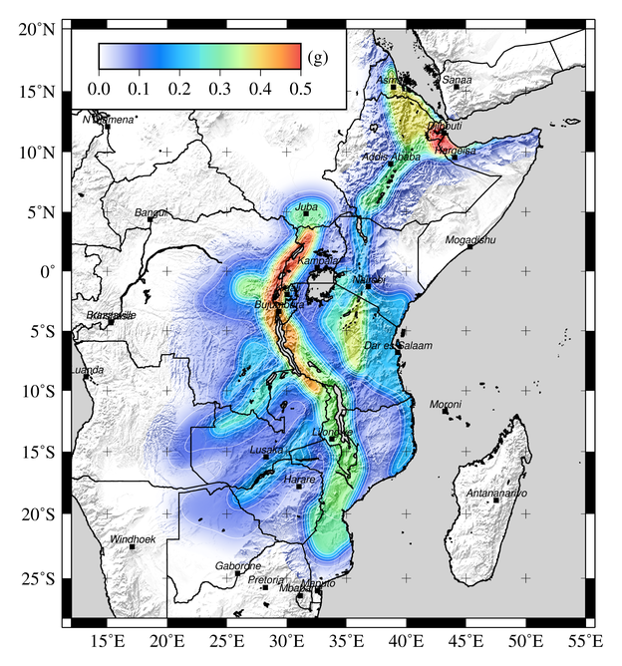

Figure 4. Map of spectral acceleration (g) for 10% probability of exceedance in 50 years at 0.1s (10Hz).

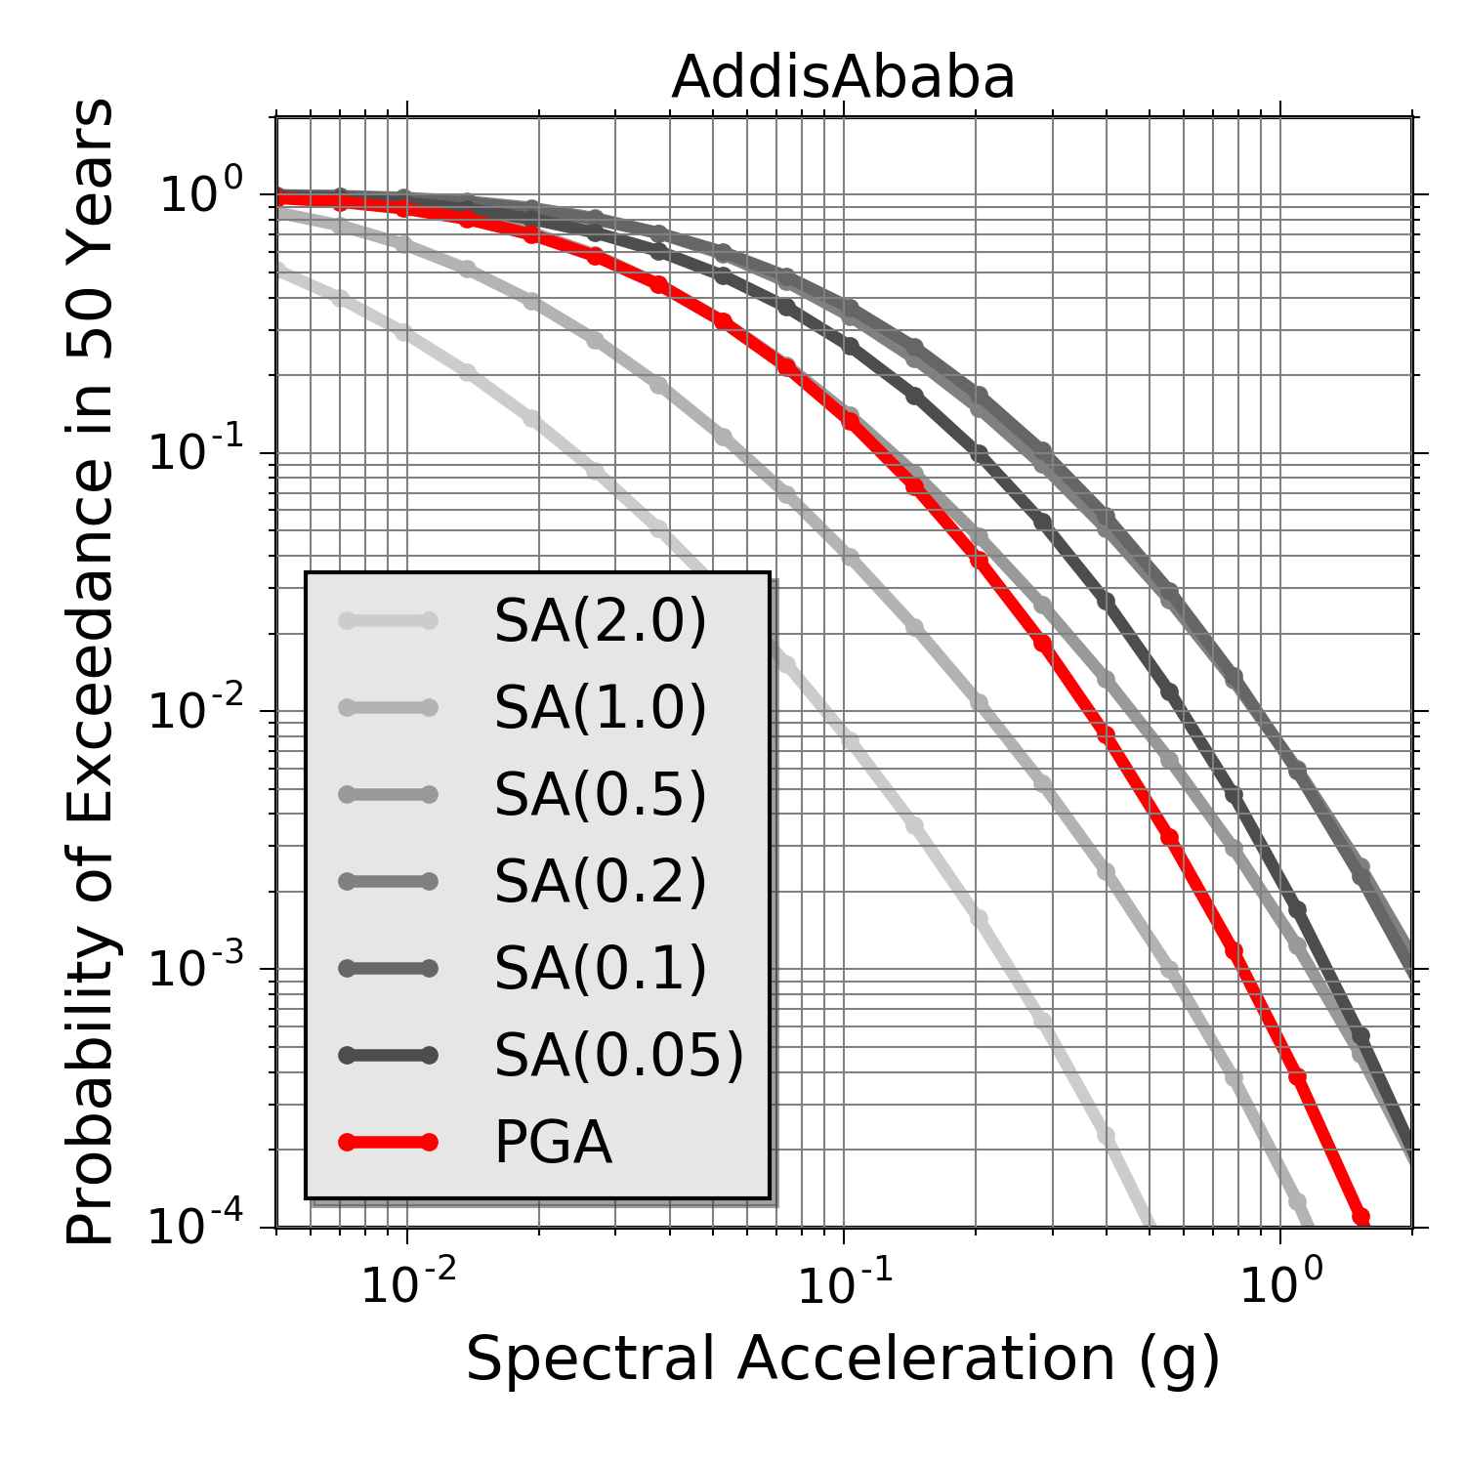 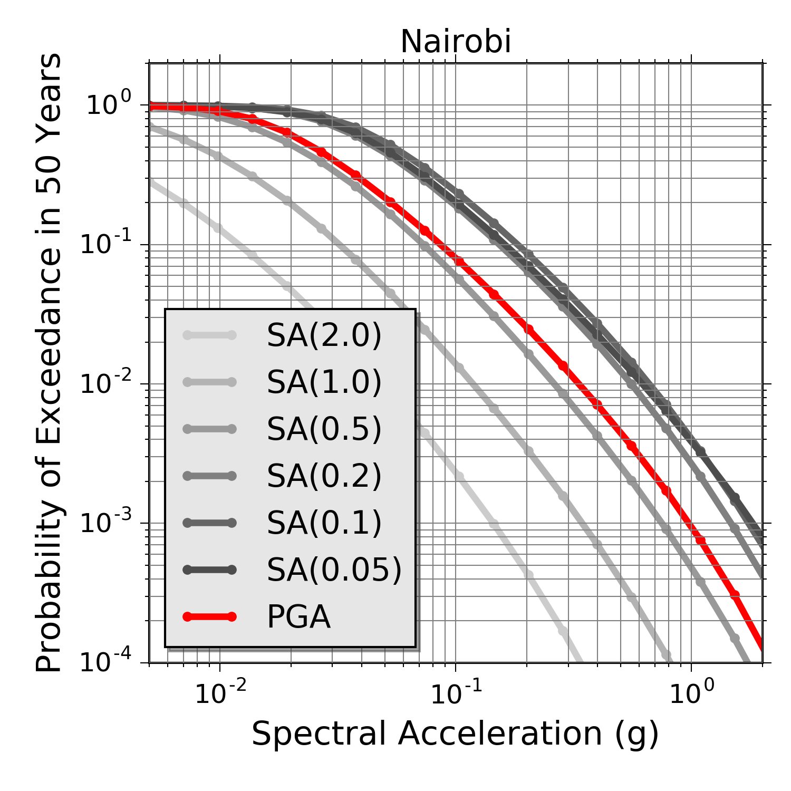

Figure 5. Mean hazard curves computed for a range of spectral periods, including PGA (in red), for two representative African capitals.

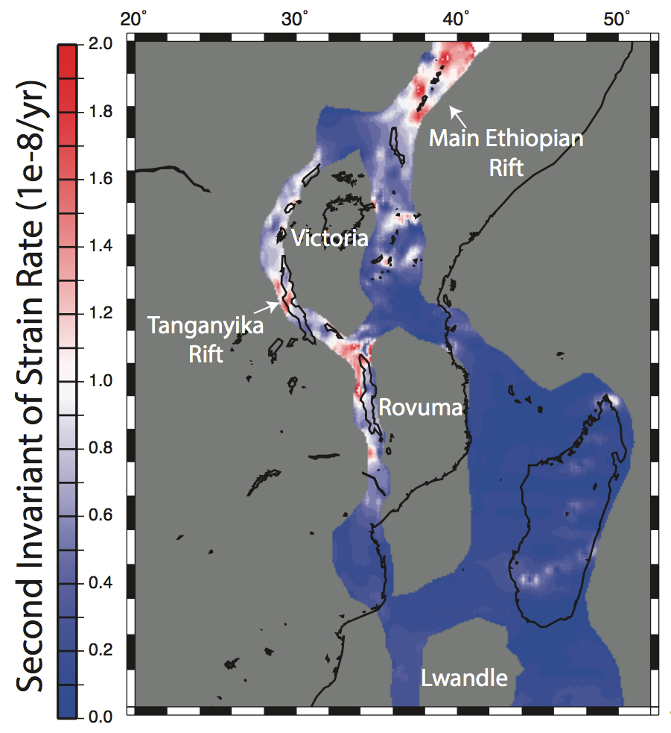

Figure 6. Second invariant of strain rate tensor of Saria et al. (2015) model.