**Seismic Hazard and Engineering Seismology**

**Spring 2019**

**Exercise #1**

**Instructor:** Dr. Valerio Poggi

**Teaching Assistant:** Onur Deniz Akan

**Assigned:** April 5th - Friday

**Due:** April 10th - Wednesday

Please, briefly, answer the questions below with short paragraphs and pictures. You may open this pdf document with OpenOffice/Word and fill-in, create a brand-new file to write your answers or prepare a neat hand-written copy to submit your work.

# The far field displacement in the direction n due to a force couple is computed by the Green’s function. Intuitively, draw the radiation pattern and the directions of the P and S wave displacements at the stations A-H. (The second force couple in the perpendicular direction is not drawn below to present a cleaner plot)

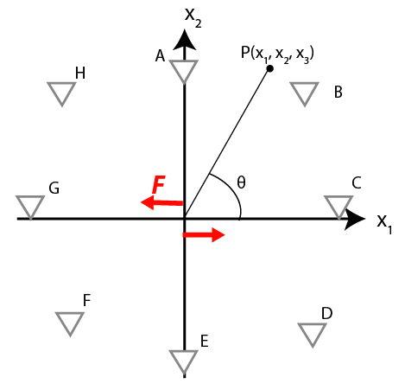

# Please identify the strike, dip and the mechanism of the following beach balls.

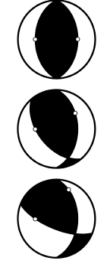

# Go to the European Strong Motion (ESM) database by following the link (https://esm.mi.ingv.it). Under data search click on events button and search for Event name “IZMIT” by typing in. Scroll down to the very bottom of the page and note the Mw 7.6 event with the event date-time: 1999-08-17 00:01:38. Follow the hyperlink to the event page by clicking on the date-time information (note that this entry gets highlighted while hovering the mouse on the top of it). Note the event map on the right. Dismiss any warning by clicking on “ok” and see the epicentre as the star, ruptured part of the North Anatolian Fault as the red line and the strong motion stations recorded the earthquake.

## Please insert a screenshot of the map as a picture and briefly type basic details of the event, tectonic setting of the region, characteristics of the faulting, rupture direction and length, and finally the depth of the epicentre.

[**Hint:** You may check Implications for Earthquake Risk Reduction in the United States from the Kocaeli, Turkey, Earthquake of August 17, 1999 published by USGS (2000)]

Go ahead and zoom on the city of Düzce and find the strong motion station with the id **TK.8101** (alternatively should be the first station in the list) and follow the link to the station page by clicking on the station id in the list below the map. Take note of the station coordinates. We will use this information in the following steps.

Then scroll to the bottom of the page and click on the **Station Records** and see all the earthquakes recorded this station. Find the **Mw 7.6, 17th of August** event (second in the list) note the magnifying glass icon corresponding to the event at the rightmost side of the page and click on it to follow the link to the **waveform** page.

## Export the acceleration record by clicking on the export button in the waveform page and download the signal. You will need to **register** to the database to export a record. However, this should be relatively quick. Once registered, click on the message generated in the page to download the record. Open three components with a word processor to read the record information, TK.8101..**HNE**.D.19990817.000138.C.ACC.ASC is the East-West component for example, and plot time versus acceleration graphs in a spreadsheet processor. Then, identify roughly the P and S wave arrival times. Time column is calculated by cumulating the time step (available in the header of the downloaded record once opened) for each acceleration line. Finally, by using three components, compute the azimuth.

## For the crust of Marmara region search for a β (Vs) and α (Vp) value and using the East-West component of the “IZMIT” earthquake record plotted in the previous part, calculate the distance of the strong motion station to the epicentre of the earthquake (show calculations) using X (km) = V (km/s). t (sec). Compare your answer with the distance information given in the database. Are they any potential sources of error? Now, it is possible to identify the epicentre of the earthquake (as a distance and a heading) from Düzce station. Compare, in few words, the orientation of the computed epicentre with the ESM database.

[**Hint:** Check article Lithospheric Structure of the Marmara and Aegean Regions, Western Turkey (Horasan et al. 2002)]

## Additional to the Düzce station, coordinates of two more stations and their distances to the epicentre are given below. Please compute the epicentre of the earthquake again, by using basic triangulation approach this time.

|  |  |  |  |  |
| --- | --- | --- | --- | --- |
| **Station Code** | **City** | **Lat.** | **Long.** | **Epicentral Distance (km)** |
| TK.1404 | Göynük | 40.39659 | 30.78307 | 80.70 |
| TK.4106 | Gebze | 40.78627 | 29.45003 | 42.8 |

## According to USGS, the nodal planes associated with this event are given in Table 3.1.

Table 3.1. Fault plane solution of the Izmit earthquake given by USGS

|  |  |  |  |
| --- | --- | --- | --- |
| Plane | Strike | Dip | Rake |
| NP1 | 178o | 74o | 9o |
| NP2 | 86o | 81o | 164o |

Draw the “beach ball” of this earthquake. Identify the “real” fault plane. Discuss the mechanism of this earthquake (Dextral/Sinistral Strike-Slip, Normal, Reverse).

# Historical fault plane solution maps are often used (as an alternative tool) for interpreting the tectonic setting of seismic regions. Below, at Figure 4.1, such a map for Aegean Sea can be seen.

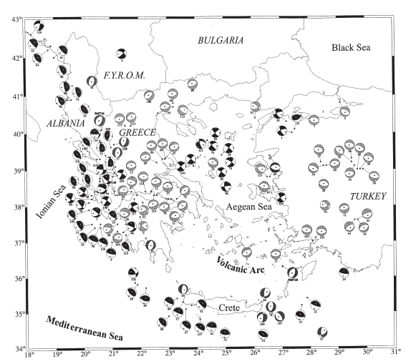

Figure 4.1. Fault plane solutions of shallow earthquakes of the period 1953-1995 with M≥5.5. A (Papazachos et al., 1998)

## Please interpret the given tectonic system at Figure 4.1. and make propositions regarding the possible tectonic boundaries and faulting mechanisms. Compare Figure 4.1. with Figure 4.2. and discuss if both maps are confirming each other.

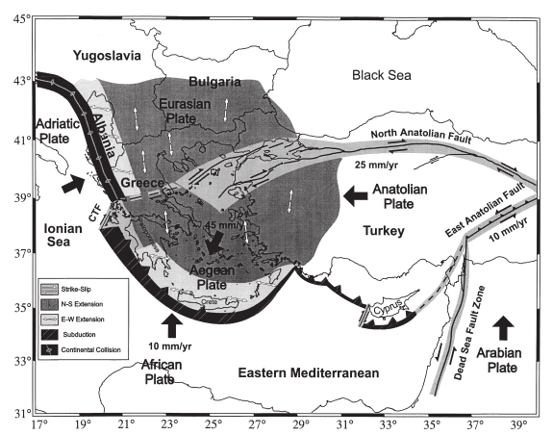

Figure 4.2. Simplified map of the Aegean Sea and the surrounding area showing the large plates involved in the active tectonics (Papazachos et al., 1998)

# In between 1811 and 1812, a series of three M 7.3-7.5 earthquakes happened in New Madrid, Missouri. Despite becoming famous as the biggest events ever recorded in United States, these earthquakes were also felt as far away as New York City, Boston and Montreal. The anomalously large area of influence of the first 1811 New Madrid earthquake can be seen at Figure 5.1.

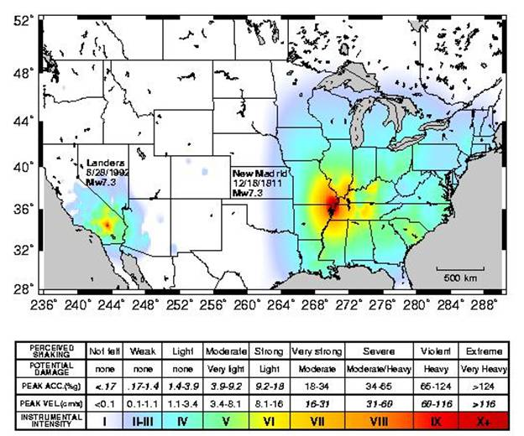

Figure 5.1. Shake-map for the Arkansas earthquake December 16,1811 (Hough et al., 2000)

## What might be a reasoning for such a large felt area?

[**Hint:** Check 1811-1812 New Madrid Earthquakes Overview from Otto W. Nuttli (1974)]