**Engineering Seismology and Seismic Hazard**

**Spring 2019**

**Exercise #2**

**Instructor:** Dr. Valerio Poggi

**Teaching Assistant:** Onur Deniz Akan

**Assigned:** April 12th - Friday

**Due:** April 17th – Wednesday

Please, briefly, answer the questions below with short paragraphs and drawings, then submit your work as a pdf document. You may open this pdf document with OpenOffice/Word and fill-in or create a brand-new file to write your answers.

# Long term earthquake prediction is proven to be impossible numerous times. Parkfield, California is one of the most notable earthquake prediction experiments done in the literature. In 1985, noting the somewhat regular characteristics of a certain part of the San Andreas Fault in California, scientists from USGS designed an experiment to predict the year of the upcoming event and densely instrumented the Parkfield section of fault system with the aim of recording a significantly large event from a near distance. Below, at Figure 1.1, there is the famous seismic cycle of the Parkfield fault. By observing the seismic cycle of this fault segment, Bakun and Lindh proposed that Parkfield fault presents a major characteristic behavior and the next earthquake might be more or less predictable by looking at the previous events.

[***For more information***: <https://earthquake.usgs.gov/research/parkfield/bakunLindh85.html>]

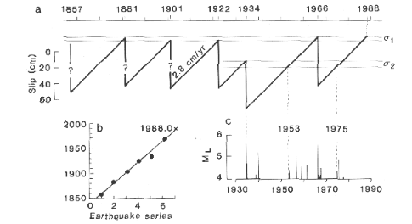

Figure 1.1. (a) Parkfield seismic cycle. σ1 and σ2 represents the failure stresses. (b) Linear regression of the time of the earthquake sequence excluding the 1934 event. (c) Shocks with ML greater than 4.0 (Bakun & Lindh, 1985)

## Please describe the steps and the properties of the seismic cycle for a system shown in Figure 1.1 and also, explain briefly, what is the argument tried to be proven with the Figure 1.1.a by the authors?

## According to USGS 1966 Parkfield earthquake was a ML (Local Magnitude) 5.6 event. Using the scaling law proposed by Wells & Coppersmith 1994, obtain a rupture length and area for this event.

## If the shear modulus (μ) for the California region is 27 GPa, compute the seismic moment released by this earthquake.

## By the time that Bakun & Lindh proposed this prediction experiment in 1985, the latest around Mw 6.0 earthquake was the 1966 event. Make a prediction on the year of the next Mw 6.0 earthquake and compare with the proposition done by Bakun & Lindh. (Show calculations)

$$M_{w}=\frac{2}{3}log⁡(M_{0})-6.07 where M_{0} is in Nm$$

## The anticipated Mw 6.0 event came on September 28th, 2004. Does it comply with the expectations? If not, what might be the fundamental reasoning behind the failure of this experiment?

## Who is C. Allin Cornell? Why is he famous for the Earthquake Engineering community? How is he related to the Alibey Dam in Istanbul?

[***Hint*:** Skim through the article Probabilistic seismic hazard analysis: Early history (McGuire 2008)]

## Cornell et al. (1979) proposed the following simplified GMPE based only on three terms: site coefficient, source term based on Mw and a propagation term with epicentral distance. However, without the associated standard deviation, GMPE’s are useless. Check Baker (2008) which is an extended summary of the PSHA procedure that is available in the material folder of the course folder at the seismo database and return a sigma value associated with this GMPE. Finally, plot the GMPE for magnitude 6 as a mean curve and +- std. dev.



## Figure 2.1. illustrates the dataset use by Campbell and Bozorgnia (2013) to calibrate the GMPE: CB13. By studying the plot, in what ranges would you trust using this GMPE?

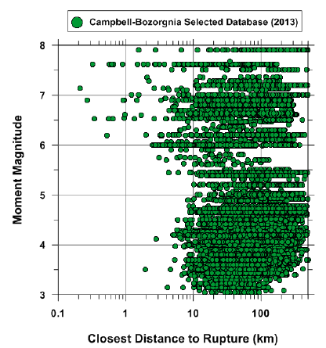

**Figure 2.1. Distribution of recordings with magnitude and distance used in the calibration of CB13 (Campbell & Bozorgnia, 2013)**

# Figure 3.1 shows the zoning done for an individual PSHA study for the cities Siena, Perugia and San Marino. For this study, the declustered earthquake catalogue of Italy is used. First the completeness intervals are studied and then several area sources are created according to common characteristics of the regions such as the seismotectonic properties and associated fault systems.

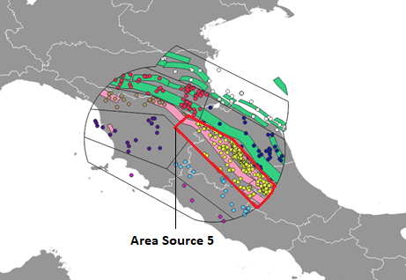

**Figure 3.1. Siena-Perugia-San Marino PSHA Source Model: Area Source 5 vs Faults and Events**

Complete and declustered catalogue for Zone 5 is given as Perugia.csv in the Exercise #2 folder at seismo database. Table 3.1 shows the completeness intervals for magnitude bins. A given year indicates that events in the corresponding magnitude bin are completely recorded since the given year until today.

**Table 3.1. Completeness of the Magnitude bins**

|  |  |  |  |  |  |  |  |  |
| --- | --- | --- | --- | --- | --- | --- | --- | --- |
| **Mw** | 3.50 | 4.00 | 4.50 | 5.00 | 5.50 | 6.00 | 6.50 | 7.00 |
| **Year** | 1990 | 1990 | 1950 | 1890 | 1780 | 1280 | 1010 | 1000 |

## 

## Compute the Annual and Cumulative Annual Rate of Exceedances of the given bins and fit a Gutenberg-Richter function to the catalogue data with Least Square regression (optional: redo with Maximum Likelihood method).

## Plot the above graph in terms of probability of exceedance in 50 years.

## Compute the magnitude of earthquakes with the 500 and 2500 years of return periods.

# Please find the Displacement-Time record of the Amatrice 2016 earthquake recorded in the Amatrice station in the Exercise folder named as IT.AMT..HGN.D.20160824.013632.C.DIS. For this record, plot and compute the following IMs: PGD, PGV, PGA and Significant Duration (D5,95)

# In the exercise folder, several hazard curves for the Algiers region are given in the Algiers_HC.csv file.

## Plot the given Hazard Curves in a spreadsheet processor.

## Compute and plot the Uniform Hazard Spectra for 2% and 10% in 50 years.